|  |  |  |  |  |
| --- | --- | --- | --- | --- |
|  | S1 | S2 | S3 | S4 |
| L | 1 | 0 | 0 | 1 |
| U | 1 | 1 | 0 | 0 |
| C | 0 | 1 | 1 | 0 |
| A | 1 | 0 | 0 | 0 |
| S | 0 | 0 | 1 | 1 |

QUESTÃO 01:

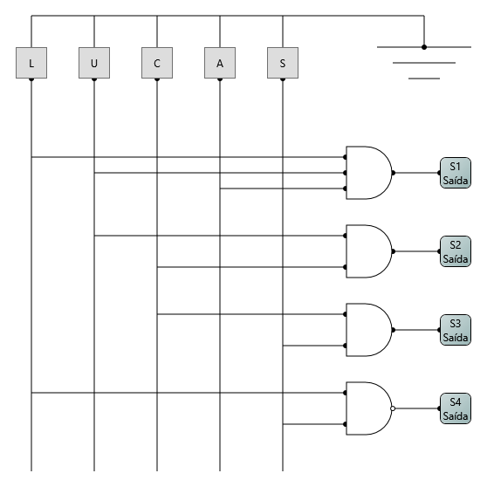

QUESTÃO 02:

|  |  |  |
| --- | --- | --- |
| Caractere | Display | Código  S1 S2 S3 S4 |
| L |  | **1 0 0 1** |
| U |  | **1 1 0 0** |
| C |  | **0 1 1 0** |
| A |  | **1 0 0 0** |
| S |  | **0 0 1 1** |

Código para 14 segmentos

|  |  |  |  |  |  |  |  |  |  |  |  |  |  |  |
| --- | --- | --- | --- | --- | --- | --- | --- | --- | --- | --- | --- | --- | --- | --- |
|  | A | B | C | D | E | F | G1 | G2 | H | I | J | K | L | M |
| L | 0 | 0 | 0 | 1 | 1 | 1 | 0 | 0 | 0 | 0 | 0 | 0 | 0 | 0 |
| U | 0 | 1 | 1 | 1 | 1 | 1 | 0 | 0 | 0 | 0 | 0 | 0 | 0 | 0 |
| C | 1 | 0 | 0 | 1 | 1 | 1 | 0 | 0 | 0 | 0 | 0 | 0 | 0 | 0 |
| A | 1 | 1 | 1 | 0 | 1 | 1 | 1 | 1 | 0 | 0 | 0 | 0 | 0 | 0 |
| S | 1 | 0 | 1 | 1 | 0 | 1 | 1 | 1 | 0 | 0 | 0 | 0 | 0 | 0 |

- Segmentos escolhidos para fazer o mapa de Karnaugh e desenhar o circuito:

**A; B; C; D; G1**

Mapa de Karnaugh para o segmento A:

Obs: S1 e S2 se referem à vertical; S3 e S4 se referem à horizontal

|  |  |  |  |  |
| --- | --- | --- | --- | --- |
| S1 S2 | S3 S4 | 00 | 01 | 11 | 10 |
| 00 | X | X | 1 | X |
| 01 | X | X | X | 1 |
| 11 | X | X | X | X |
| 10 | 1 | X | X | X |

Expressão simplificada (Segmento A):  
__ __ __ __ __ __ __  
S1.S2.S3.S4 + S1.S2.S3.S4 + S1.S2.S3.S4

Mapa de Karnaugh para o segmento B:

|  |  |  |  |  |
| --- | --- | --- | --- | --- |
| S1 S2 | S3 S4 | 00 | 01 | 11 | 10 |
| 00 | X | X | X | X |
| 01 | X | X | X | X |
| 11 | 1 | X | X | X |
| 10 | 1 | X | X | X |

Expressão simplificada (Segmento B):

__ __  
S1.S3.S4

Mapa de Karnaugh para o segmento C:

|  |  |  |  |  |
| --- | --- | --- | --- | --- |
| S1 S2 | S3 S4 | 00 | 01 | 11 | 10 |
| 00 | X | X | 1 | X |
| 01 | X | X | X | X |
| 11 | 1 | X | X | X |
| 10 | 1 | X | X | X |

Expressão simplificada (Segmento C):

__ __ __ __  
S1.S3.S4 + S1.S2.S3.S4

Mapa de Karnaugh para o segmento D:

|  |  |  |  |  |
| --- | --- | --- | --- | --- |
| S1 S2 | S3 S4 | 00 | 01 | 11 | 10 |
| 00 |  |  | 1 |  |
| 01 |  |  |  | 1 |
| 11 | 1 |  |  |  |
| 10 |  | 1 |  |  |

Expressão simplificada (Segmento D):

__ __ __ __ __ __ __ __  
S1.S2.S3.S4 + S1.S2.S3.S4 + S1.S2.S3.S4 + S1.S2.S3.S4

Mapa de Karnaugh para o segmento G1:

|  |  |  |  |  |
| --- | --- | --- | --- | --- |
| S1 S2 | S3 S4 | 00 | 01 | 11 | 10 |
| 00 | X | X | 1 | X |
| 01 | X | X | X | X |
| 11 | X | X | X | X |
| 10 | 1 | X | X | X |

Expressão simplificada (Segmento G1):

__ __ __ __ __   
S1.S2.S3.S4 + S1.S2.S3.S4

**Circuito:**

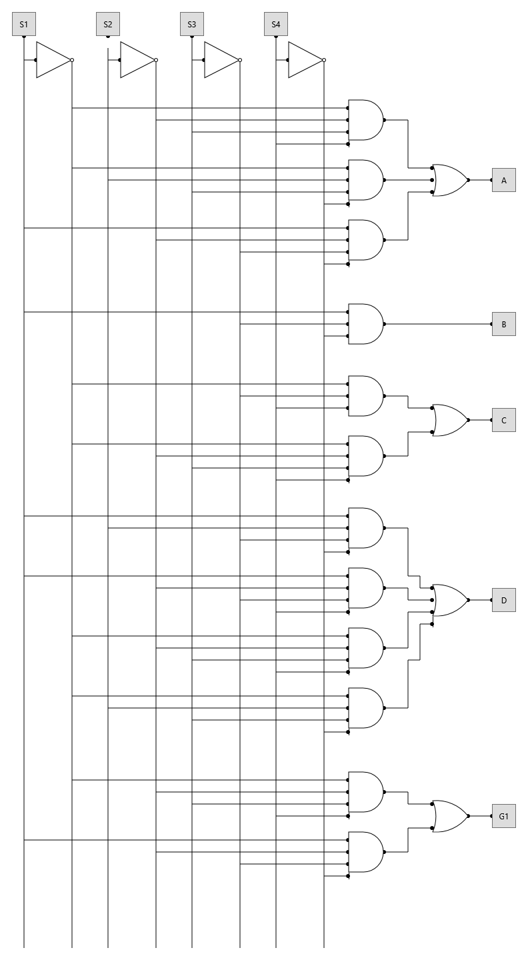

QUESTÃO 03:

**1 1**

**1 1 0 1**

**+ 0 1 1 0**

**1 0 0 1 1**

